Decoding Music Genres Through Physical Acoustic Features
- Introduction：
Scientific Background: Physical acoustics and digital audio signal processing form the scientific foundation for understanding musical signals. Sound, as a mechanical wave, has physical properties (frequency, amplitude, etc.) that can be quantified into computable audio features in modern audio analysis, such as Spectral Centroid (sound sharpness/brightness) and Chroma Features (energy distribution of tone).
Motivation: Music is an important carrier of human cultural evolution, originating from different sound forms. Can musical genres be clearly distinguished based on physical acoustic features? If so, music creators could gain better creative inspiration and more precise song categorization from these physical acoustic features, thereby enhancing their production quality.

- Dataset Description：
Source: GTZAN Dataset - Music Genre Classification (Olteanu, 2020).（features_30_sec.csv）
Scale (1000×60): The dataset includes 10 music genres ('label') (such as Blues, Jazz), with 100 audio clips for each genre. Each row represents a 30-second audio clip. Apart from 'filename', 'length', and 'label', the remaining columns are physical acoustic features. Essentially, each feature has its respective mean value column and variance value column, with only the 'tempo' column (rhythm speed) having neither mean nor variance values.
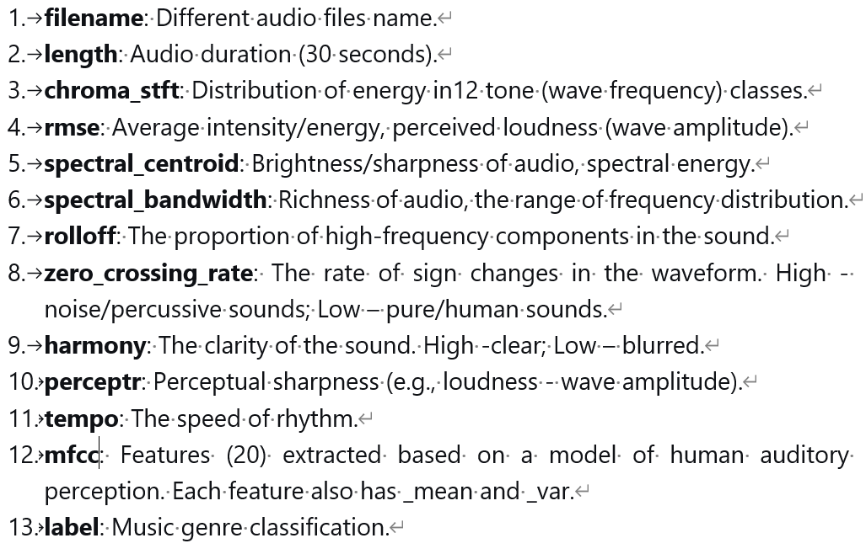
Correlation: The different physical acoustic features in this dataset collectively contribute to the final music genre classification and can be used to explore the relationships between them.

- Key Findings and Insights：
  - Insight 1：
Observation: Importance of physical acoustic features in determining music genres.
Experiment: Uses Random Forest model's built-in method (feature_importances_), automatically calculates important scores for each feature, and ranks in descending order.
Results: The top 5 most important features are: ‘chroma_stft’ (0.0746), ‘rms’ (0.0697), ‘mfcc4’ (0.0587), ‘mfcc1’ (0.0498), and ‘rolloff’ (0.0453).
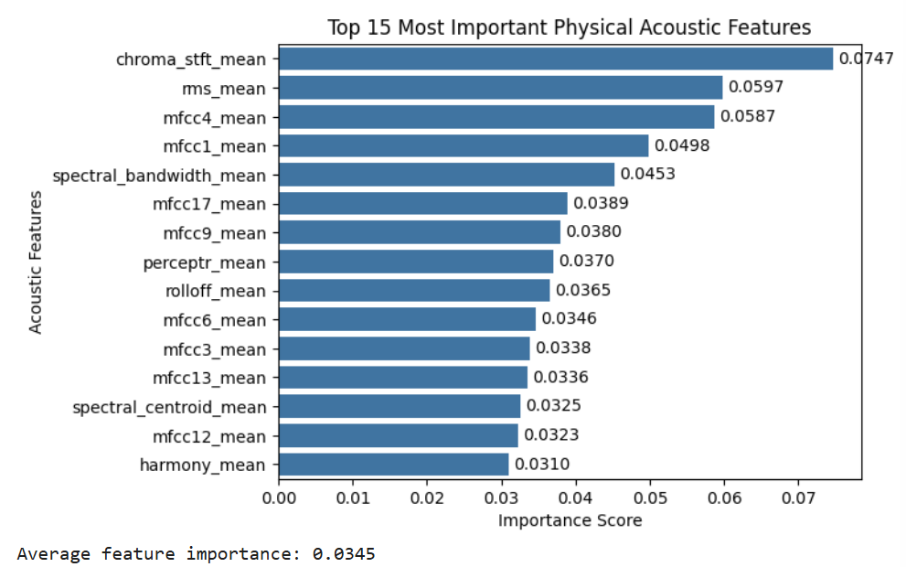
Insight: ‘chroma_stft’ (tone energy distribution) is the most important feature for distinguishing music genres, with ‘rms’ (average intensity/energy) and ‘mfcc4’ (human auditory feature) also playing key roles. Reflect that different genres of music may exhibit differences in the distribution of high frequency energy.
Value: These findings provide key feature selection basis for music information retrieval systems. Focusing on chroma, energy, and MFCC features can significantly improve the accuracy and efficiency of classification.
Action Recommendations: Develop intelligent mixing plugins: Create automated mixing tools based on ‘chroma_stft’ features. When energy distribution characteristics like a particular genre are detected, automatically recommend corresponding equalizer and compressor parameter settings.

  - Insight 2：
Observation: Clustering phenomenon of music genres in the reduced-dimensional space.
Experiment: Using Principal Component Analysis to condense 29 acoustic features into 2 core feature dimensions (the two most distinguishing feature dimensions that best capture data variation), then plotting a scatter chart to analyze similarity between music genres.
Results: The first two principal components collectively explain approximately 50% of the total variance in the original data. These two feature dimensions can explain half of the variation patterns in the original data, with each genre forming distinguishable clusters.
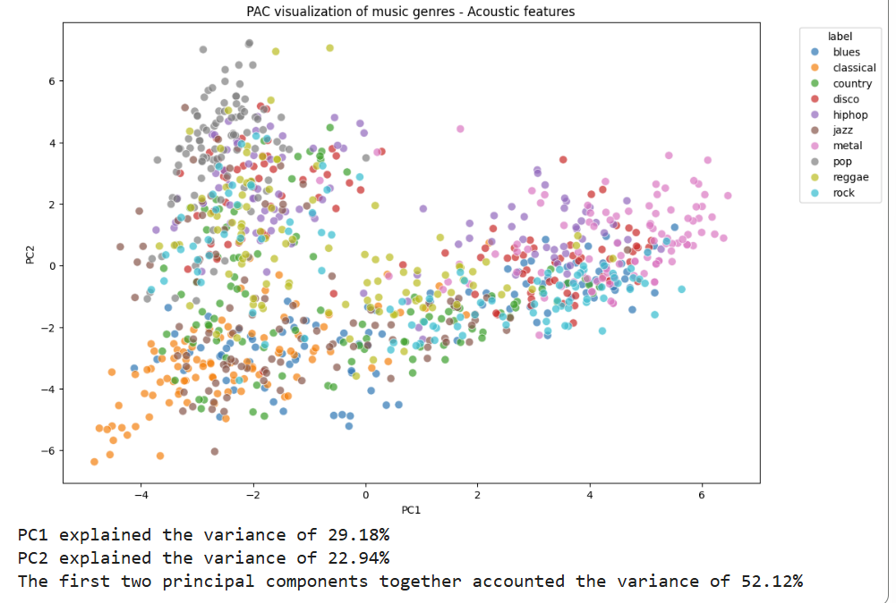
Insight: Natural clustering of genres reveals unique acoustic features, with adjacent clusters indicating similar acoustic properties and musical styles. Reflect that music genres have a clear structural separation in the acoustic feature space.
Value: Provides data-driven evidence for understanding evolutionary relationships and style fusion between music genres and enables acoustic similarity-based genre association analysis for music information retrieval and recommendation systems.
Action Recommendations: Recommend "disco" music to users who like "mental" music, as these genres are adjacent in the acoustic feature space.

  - Insight 3：
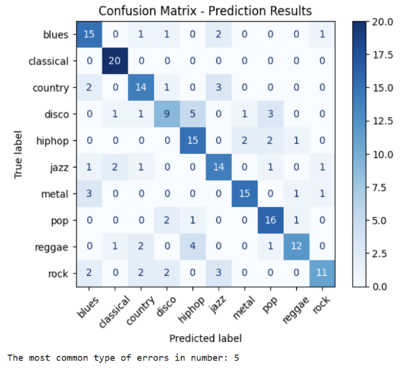
Observation: Music genres that are easily confused have relatively high acoustic similarity.
Experiment: Analyze and plot the confusion matrix from a Random Forest classifier’s prediction to identify the most frequent misclassification patterns.
Results: ‘disco’ → ‘hiphop’ shows the highest confusion numbers (5), followed by ‘reggae’ → ‘hiphop' (4). In contrast, 'classical' had 0 errors.
Insight: Frequent misclassification between specific genre pairs indicates acoustic similarity, revealing natural relationships within the musical feature space and enabling the identification of the most similar music genres. The perfect identification of 'classical' also highlights the uniqueness of its acoustic features.
Value: These patterns of acoustic similarity can inform music recommendation algorithms and aid in understanding the evolutionary connections between different musical styles.
Action Recommendations: Music creators can refer to the confusion matrix to choose genres with similar acoustic features for stylistic fusion in their compositions (e.g., the low confusion between 'disco' and 'jazz' suggests that fusing these two genres would be highly challenging).

  - Insight 4:
Observation: Certain acoustic features stimulate the human auditory system significantly more than others.
Experiment: Use Correlation analysis and bar chart to rank the level of stimulation.
Results: The feature 'harmony' exhibited the strongest correlation with perceived stimulation level (r=0.568), with an influence more than twice that of the second-ranked feature 'mfcc6' (r=0.251).
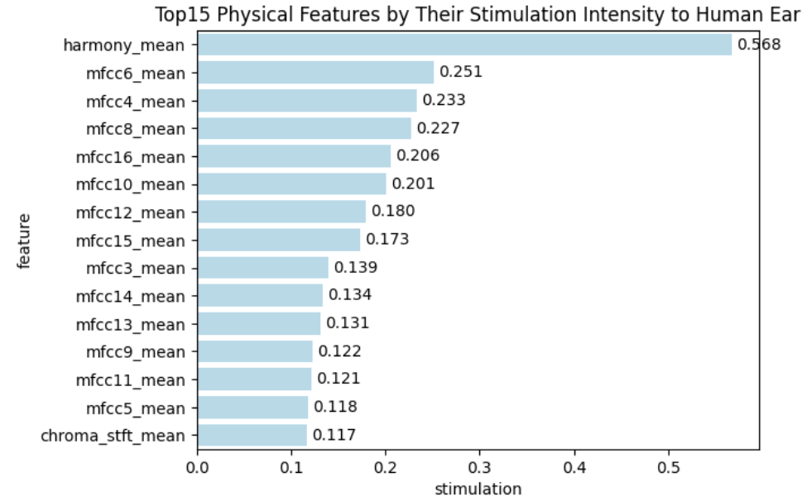
Insight: “harmony” is the dominant acoustic factor to determine sound stimulation levels and can control reactions from the human ear.
Value: This finding provides important guidance for audio engineering and sound design, as precisely controlling the 'harmony' feature can effectively regulate the stimulation level of audio content on the human ear.
Action Recommendations: In audio post-production, sound designers can intentionally reduce 'harmony' to create tension or startling effects (for example, horror movies can use dissonant sounds or introducing abrupt loudness changes following silence).

  - Insight 5：
Observation: The influence of different acoustic features on the energy distribution ('chroma_stft') of sound waves.
Experiment: Used a multiple linear regression model with various acoustic features as independent variables to predict music energy levels.
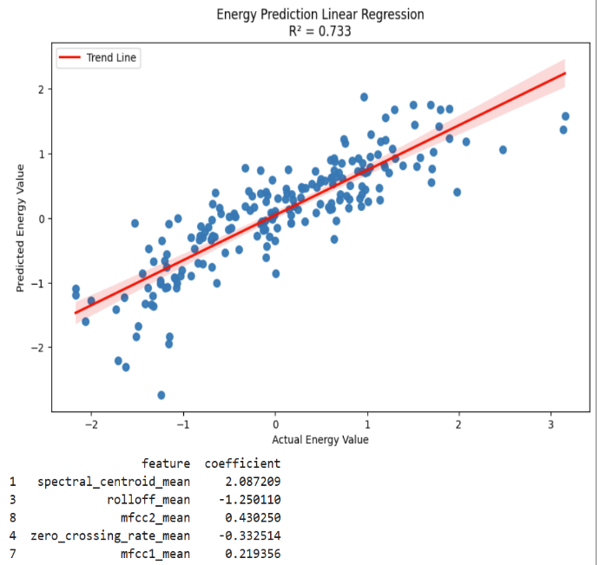
Results: Prediction accuracy R²=73.3%. 'spectral_centroid' (sound brightness/sharpness, frequency energy) is the strongest predictive feature (2.087), follow by 'rolloff' (-1.250) and 'mfcc2' (0.430).
Insight: The "energy level" of music can be quantitatively predicted by a set of core acoustic features. 'Spectral_centroid' is the decisive predictor, showing a strong positive correlation with energy.
As Yang & Chen (2012, p.8) point out that the spectral centroid is one of the most prominent features for identifying music in the 'arousal' dimension, where high arousal directly corresponds to the perception of high energy.
Value: By monitoring just a few key features, the energy level of music can be automatically and accurately estimated without the need for complex subjective evaluation.
Action Recommendations: Utilize this energy model to recommend songs to users that match the energy level of their current activity. For example: working (low-energy ambience/pure music), waking up (medium-energy disco), exercising (high-energy electronic music).

Conclusion：
The differences between music genres are not only in cultural background but also in quantifiable acoustic features. By decoding these physical characteristics, it can reveal their intrinsic connection to subjective perception, thereby enabling humans to understand, predict, and design music. This discovery contributes to a solid foundation for intelligent music processing technology. Ultimately, achieving more accurate understanding and creation of music through physical features.

Reference:
- Olteanu, A. (2020). GTZAN dataset - Music genre classification [Data set]. Kaggle.
https://www.kaggle.com/datasets/andradaolteanu/gtzan-dataset-music-genre-classification
- Yang, Y.-H., & Chen, H. H. (2012). Machine recognition of music emotion: A review. ACM Transactions on Intelligent Systems and Technology, 3(3), 40.
https://www.researchgate.net/publication/254004106

